Mrs. Yohey’s Classroom News
jyohey@gcswave.com
937-548-1013 ext. 3118 February 2024
Math | Science | Social Studies
This month we are working hard on “making sense of story problems” to solve. What is exciting about this time of year, is that we can use all the strategies and known facts we’ve been focusing on to quicky get to the answers (once we determine what the story problem is asking.) | We will spend some time this month learning about forces and motion.  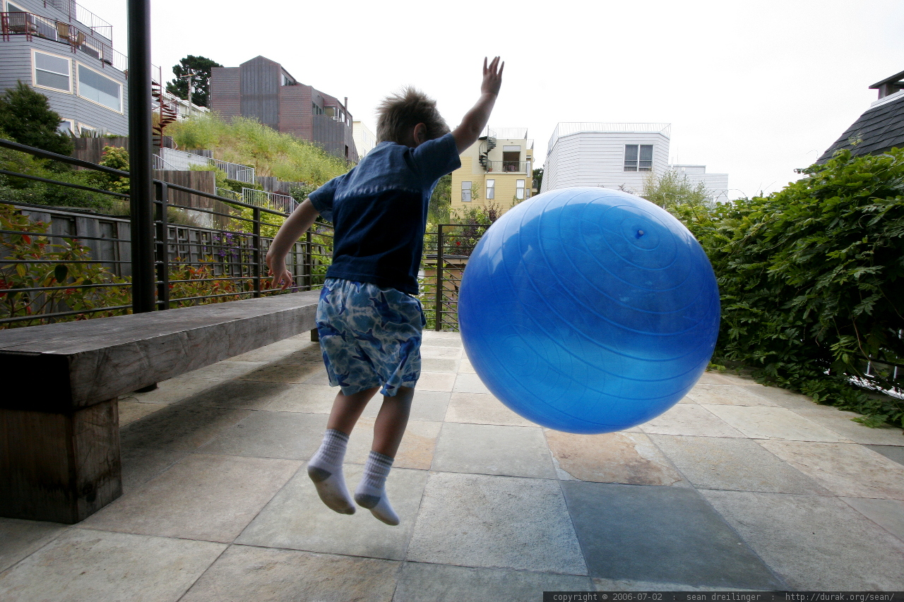 | First graders will be learning about timelines. We have an amazing project underway that allows students to show how THEY have changed over time. Please plan to have those turned in no later than next Wednesday. (Thanks!)  We will also continue to study maps.  Greenville Elementary has a character focus for each month. In February, our focus is on PERSEVERANCE!
 | LIGHT PROJECT
KEEP UP THE GREAT WORK!!
* Remember to try and keep the books for no longer than a week. I understand things come up and families get busy. If you need to keep it longer, it’s ok. Just remember we have other students waiting to check out these books.
*Reminder: You can go at your own pace. It’s ok to make a goal of 10 instead of 50. Every little bit counts. :)
Important Dates
February 5, 6, 8 Pizza Bingo and Book Fair (Bingo is from 5:30-7)
February 16 Classroom Valentine Parties!
February 19 – No School (President’s Day)

